**A GUESTURE BASED TOOL FOR RADIOLOGY IMAGES**

**IDEA 1:**

In this project we use gestures to browse images obtained during radiology. Gestures refer to non verbal form of communication made using hands. A major challenge involved in this process is to provide doctors with efficient, intuitive, accurate and safe means of interaction without affecting the quality of their work. Keyboards and pointing devices, such as a mouse, are today's principal method of human—computer interaction. However, the use of computer keyboards and mice by doctors and nurses in intensive care units (ICUs) is a common method for spreading infections. Humans can recognize body and sign language easily. This is possible due to the combination of vision and synaptic interactions that were formed along brain development.

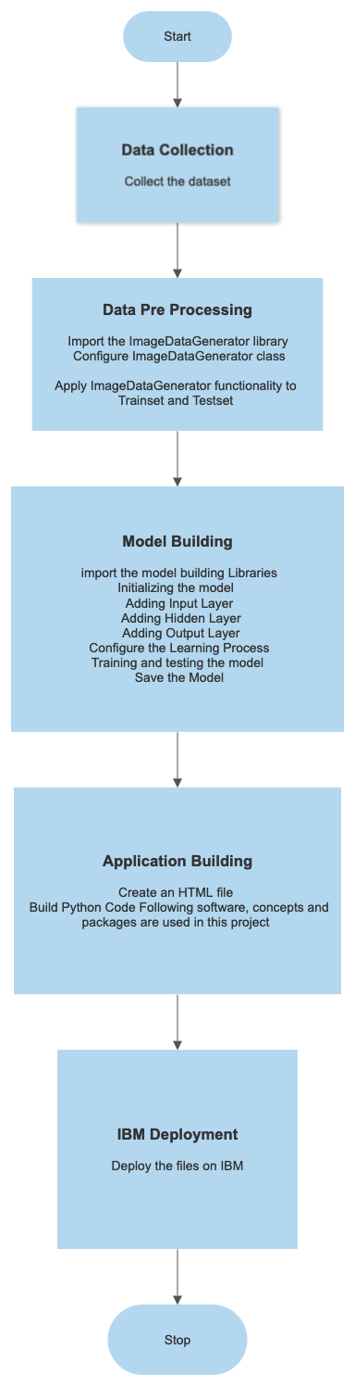

● User interacts with the UI (User Interface) to upload the image as input.

● Depending on the different gesture inputs different operations are applied to the input image.

● Once model analyses the gesture, the prediction with operation applied on image is showcased on the UI.

To accomplish this, we have to complete all the activities and tasks listed below:

**● Data Collection.**

○ Collect the dataset or Create the dataset

**● Data Pre processing**

○ Import the ImageDataGenerator library

○ Configure ImageDataGenerator class

○ Apply ImageDataGenerator functionality to Trainset and Testset

**● Model Building**

○ Import the model building Libraries

○ Initializing the model

○ Adding Input Layer

○ Adding Hidden Layer

○ Adding Output Layer

○ Configure the Learning Process

○ Training and testing the model

○ Save the Model

**● Application Building**

○ Create an HTML file

○ Build Python Code Following software, concepts and packages are used in this project

**● Anaconda navigator**

**● Python packages:**

○ open anaconda prompt as administrator

○ Type “pip install TensorFlow” (make sure you are working on python 64 bit)

○ Type “pip install opencv-python”

○ Type “pip install flask”

**IDEA 2:**

#### **Hand-Gesture Based HCI Design**

In recent years, computing technology has become embedded in every aspect of our daily lives and man–machine interaction is becoming inevitable. A gateway which allows humans to communicate with machines and computers is known as the human–computer interface (HCI) . Keyboard and mouse and touch-screen sensors are the traditional HCI approaches. However, these approaches are becoming a bottleneck for developing user friendly interfaces . Contrary to this, human gestures can be a more natural way of providing an interface between humans and computers. In this approach we are using the short-range radars which have the ability to detect micro-movements with high precision and accuracy .

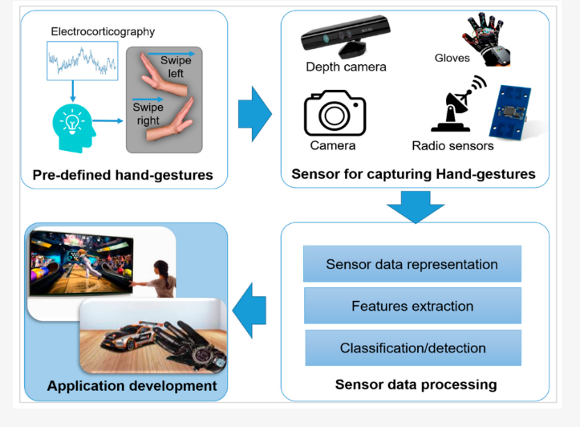

First, a neural spike is produced in the brain, which generates a signal that results in a voluntarily motion of the hand. The brain signal corresponding to hand movement can be seen through electrocorticography . To detect the hand movements, several sensors exist, such as camera, depth-camera, and radio sensors. The signal at the output of these sensors is analyzed using suitable algorithmic techniques to detect a predefined hand gesture. After successfully recognizing the desired hand-movements, these gesture-based systems can be used to classify the images based on radiology.

A wide range of sensors are available for acquiring signals against the performed hand gesture, and radar sensor is used in our approach. Traditionally, optical sensors (camera), and wearable sensors (gloves) are widely used. These sensors can be classified as wearable and non-wearable. It can be seen that both types of technology possess their own strengths and weaknesses and can be selected according to the requirements of the application in consideration. Both the radar and the cameras provide a wireless interface for gesture recognition. Radar sensors have several benefits over camera-based recognition systems . Radar is not affected by lightning conditions and there are no related privacy issues. Users often do not feel comfortable being watched by a camera.

After data acquisition, the next step is processing the data and recognizing hand gestures. This includes data representation, useful features extraction, and classification. The classification can be performed by using signal-processing approaches,traditional machine learning or deep learning approaches.

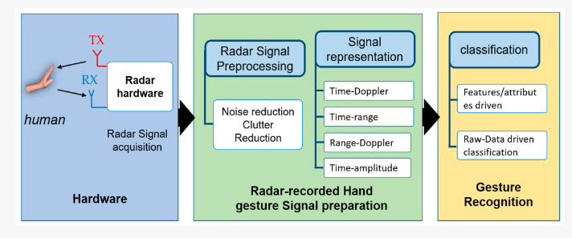

Predefined hand gesture is performed by users in radar cross-sectional area.This signal is passed through a clutter reduction filter and the signal is represented in any of the mentioned signal representation schema. Finally,recognition is performed.

1. Hand-gesture movement acquisition, where one of the available radar technologies is chosen;
2. Pre-processing the received signal, which involves pre-filtering followed by a data formatting which depends on step 3. For example, the 1D, 2D, and 3D deep Convolutional Neural Network (DCNN) will, respectively, require data to be in a 1D, 2D or 3D shape;
3. The final step of hand-gesture classification produces the various classification of the image. If the gesture prediction is 1 then images is blurred;2, image is resized;3,image is rotated etc.

**IDEA-3:**

**“Hand Gesture Recognition Using Camera ”**

“Hand Gesture Recognition Using Camera ” is based on concept of Image processing. In recent year there is lot of research on gesture recognition using kinect sensor on using HD camera but camera and kinect sensors are more costly. This idea focuses on to reduce cost and improve robustness of the proposed system using simple web camera .

The sterile gesture interface consists of a Canon VC-C4 camera, whose pan/tilt/zoom can be initially set using an infrared (IR) remote. This camera is placed just over a large flat screen monitor . Additionally, an Intel Pentium IV, (600MHz, OS: Windows XP) with a Matrox Standard II video-capturing device is used.

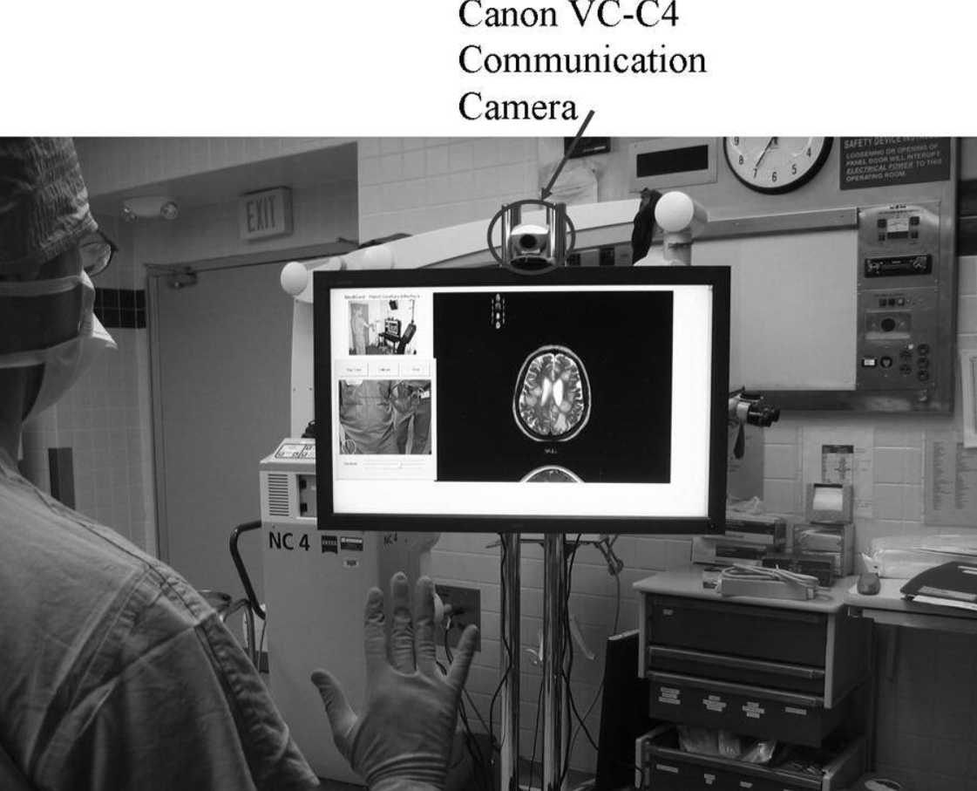

A two layer architecture is used: In the lower level “Gestix” provides tracking and recognition functions, while at the higher level a graphical user interface called “Gibson” manages imaging visualization.

### The Tracking Algorithm:

After a short calibration process, where a probability color model of the doctor's hand is built, images of the surgeon's hand gesturing are acquired by video-camera and each image is back-projected using a color model. The hand is then tracked by an algorithm which segments it from the background using the color model back-projection and motion cues. [7](https://www.ncbi.nlm.nih.gov/pmc/articles/PMC2410001/#bib7) This is followed by black/white thresholding, and a sequence of opening and closing morphological operations resulting in a set of components (blobs) in the image. The location of the hand is represented by the 2D coordinates of the centroid of the biggest blob in the current image.

### “Gibson” Image Browser:

The “*Gibson*” image browser is a 3D visualization medical tool that enables examination of images, such as: MRIs, CT scans and X-rays. The images are arranged over a multiple layer 3D cylinder. The image of interest is found through rotating the cylinder in the four cardinal directions. To interface the gesture recognition routines with the “*Gibson*” system, information such as the centroid of the hand, its size, and orientation are used to enable screen operations in the “*Gibson*” graphical user interface.

### Hand Tracking and Operation Modes:

Gesture operations are initiated by a calibration mode in which a skin color model of the user's hand or glove, under local lighting, is constructed. In a browse mode, superimposed over the image of the camera's scene is a rectangular frame called the “neutral area.” Movements of the hand across its boundary constitute directional browser commands. When a doctor/surgeon wishes to browse the image database, the hand is moved rapidly out of the “neutral area” toward any of four directions, and then back again. When such a movement is detected, the displayed image is moved off the screen and replaced by a neighbor image. To evoke a zoom mode, the open palm of the hand is rotated within the “neutral area” clockwise/counterclockwise (zoom-in/zoom-out). To avoid the tracking of unintentional gestures, the user may enter a “sleep mode” by dropping the hand. To re-arouse the system the user waves the hand in front of the camera. The selection of these gestures was designed to be intuitive, expressing the “natural” feeling of the user. For example, the left/right/up/down gestures evoke the actions used to turn pages in a book left/right, or flip notepad pages up/down. The rotation gesture (zoom-in/zoom-out commands) reminds one of a radio knob to increase or decrease volume. Dropping the hand (stop-tracking command) is associated to the idea of ‘stop-playing', while the waving gesture (“wake-up” command) is associated with ‘greeting a new person’.